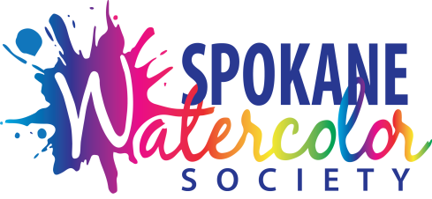
Spokane Watercolor Society
Juried Member Show 2022
Entry Form

Exhibition Dates: September 2nd-September 30th,2022
Location: Spokane Art School Gallery (SASG)
Contact: SWS Juried Member Show Chairperson: Kelly Knouff-Burk
Email snoo.kb@hotmail.com Phone/Text: (509) 998-8376

Entry Fees: $20.00 for 1st entry and $10.00 for 2nd. Payable online beginning May 8th.
All fees are non-refundable.
SUBMIT COMPLETED ENTRY FORM TO: spokanewatercolorshows@gmail.com
Submit images separately per prospectus instructions.

Name: ________________________________________________________________________

Email: __________________________________ Phone: ______________________________

Entry #1

Title: __________________________________________________________________________

Medium and Substrate: _________________________________________________________

Image Size: (W):____________x (H):______________

Frame Size: (W):_______________ x (H):_______________

Sales Price: Include 40% commission to SASG): ________________

Entry #2

Title: __________________________________________________________________________

Medium and Substrate:_________________________________________________________

Image Size: (W):____________x (H):_____________

Frame Size: (W):_______________ x (H):_______________

Sales Price: (Include 40% commission to SASG): _________________

- I have read the Prospectus in full and agree to its full terms:

Signature: _______________________________________ Date: _______________________

